CQUniversity Australia
COIT20265 - Networks and Information Security
Project Client: Dr Fariza Sabrina

An NLP-Based Prototype for Anomaly Detection in
Cloud-Generated and Benchmark Cybersecurity Logs
Final Project Report

Team Member | Student ID | Role
Tahmid | [Student ID] | Project Manager
Mahin | [Student ID] | Cloud Engineer
Nafisa Sultana | [Student ID] | Software Engineer
Yeakub | [Student ID] | Data Analyst / NLP Developer

May 2026

Abstract
The objective of this report is to present the design, implementation, and evaluation of LogGuard AI - an NLP-based prototype system for detecting anomalous activity in cybersecurity logs. With the amount of log data produced by large numbers of cloud servers, authentication systems, and applications that are integrated into the network, the system is a challenge for modern organisations. In the modern log era, the volume and complexity of log data have increased significantly, and traditional rule-based detection methods cannot meet the demand for large-scale log detection, so intelligent and automatic detection methods are needed (Guo et al. 2021).
The prototype combines four machine learning and deep learning models: Random Forest, Isolation Forest, LogBER, T, and Bidirectional LSTM using a multi-source dataset of 7,254 log entries from the benchmark log repositories and from the ongoing AWS EC2 cloud infrastructure. The system is hosted on Amazon Web Services (AWS) and links together a public website, API gateway, AWS Lambda, Amazon CloudWatch, EC2, Amazon SNS, Amazon S3, and a Streamlit dashboard, creating an end-to-end automated workflow.
The Bidirectional LSTM model outperforms any other model, with an F1-Score of 0.9987 and a Recall of 1.0000 on the test set, making it very effective at catching all the anomalous log entries without missing any genuine threats. The baseline model using the Random Forest was found to have an F1-Score of 0.9971 and a ROC-AUC score of 1.0000. The complete system captures live user interaction logs from the website, analyses them using trained NLP models, and automatically sends email alerts with AI-generated security recommendations when anomalies are detected (Amazon Web Services 2024b).

Table of Contents
Abstract i
1. Introduction 1
1.1 Background 1
1.2 Problem Statement 1
1.3 Project Objectives 2
1.4 Project Scope 2
2. Literature Review - NLP in Cybersecurity 2
2.1 Evolution of Log-Based Anomaly Detection 2
2.2 BERT and Transformer Models for Log Analysis 3
2.3 LSTM Models for Sequential Log Analysis 3
2.4 Traditional Machine Learning Baselines 3
2.5 Cloud-Based Log Management and AWS Integration 4
3. System Architecture 4
3.1 High-Level Architecture Overview 4
3.2 Technology Stack 5
4. Dataset 5
4.1 Dataset Overview 5
4.2 Data Sources 6
4.3 Cloud Log Collection 7
5. Data Preprocessing 7
5.1 Preprocessing Pipeline Overview 7
5.2 Eight-Step Normalisation Pipeline 8
5.3 Text Representation Strategies 8
6. Algorithms and Models 8
6.1 Random Forest 8
6.1.1 Model Description 8
6.1.2 Configuration and Results 8
6.2 Isolation Forest 9
6.2.1 Model Description 9
6.2.2 Results 9
6.3 LogBERT 10
6.3.1 Model Description 10
6.3.2 Training Results 10
6.4 Bidirectional LSTM 10
6.4.1 Model Architecture 10
6.4.2 Training History 11
6.4.3 Test Set Results 11
6.5 Algorithm Comparison 12
7. AWS Cloud Integration Pipeline 13
7.1 Pipeline Overview 13
7.2 Stage 1 - Static Website Hosted on Amazon S3 13
7.3 Stage 2 - Website Event Logging 15
7.4 Stage 3 - API Gateway and Lambda Log Receiver 15
7.5 Stage 4 - Website Logs Stored in CloudWatch 17
7.6 Stage 5 - EC2 LogBERT Processing Environment 18
7.7 Stage 6 - LogBERT Anomaly Results as Structured JSON 19
7.8 Stage 7 - SNS Email Alerting with OpenAI Recommendations 20
7.9 Stage 8 - CloudWatch to S3 Storage for Dashboard 22
7.10 Stage 9 - Streamlit Dashboard Visualisation 23
8. Website Development 24
8.1 Website Overview 24
8.2 Website Sections and Logged Interactions 24
8.3 Login System and Security Event Logging 25
9. Streamlit Dashboard 25
9.1 Dashboard Architecture 25
9.2 Dashboard Features 25
9.3 Algorithm Integration 26
10. Evaluation and Performance Analysis 26
10.1 Evaluation Methodology 26
10.2 Comprehensive Results 26
10.3 Key Findings 27
Finding 1 - Recall is the Critical Security Metric 27
Finding 2 - Isolation Forest Demonstrates the Unsupervised Tradeoff 28
Finding 3 - Data Leakage Inflates Supervised Model Metrics 28
11. Limitations and Future Work 28
11.1 Current Limitations 28
Limitation 1 - Data Leakage from Keyword-Based Labelling 28
Limitation 2 - LogBERT Evaluation Completeness 28
Limitation 3 - Live Pipeline Integration Pending 28
11.2 Future Improvements 28
Upgrade 1 - Connect EC2 to Live CloudWatch Logs 28
Upgrade 2 - NIST Framework-Based Alert Recommendations 29
Upgrade 3 - Improve Email Thread Organisation 29
Upgrade 4 - Real-Time Streaming Pipeline 29
12. Conclusion 29
13. References 31

1. Introduction

1.1 Background
Cloud computing is an indispensable part of the day-to-day life of modern organisations. Regularly, huge amounts of log data are generated by cloud servers, web applications, authentication services, and networked systems. The logs provide important details concerning system behaviour, user activity, service events, and security incidents. Log information can be analyzed properly to find out some indications of intrusion attempts, unauthorised access, service failures, and other events that are related to security (Du et al. 2017).
The major problem with detecting threats in cybersecurity log analysis is that of scale. Thousands of log entries can be created per hour in a single cloud server. Manual review is impractical, as there are too many records to examine, and rules based on simple keywords or static threshold detection have an unacceptably high false-positive rate while failing to detect more advanced attack patterns that do not match known signatures ( Chen et al. 2021). This makes the requirement for intelligent, automatic analysis of log patterns with high accuracy, high speed, and low complexity an imperative.
One solution to the problem is through the use of Natural Language Processing (NLP). Log entries are a type of text data, consisting of a series of words, identifiers, timestamps,s and codes that can be tokenised, vectorised, and analysed with language models. Recent studies have shown that anomaly detection can be performed much more accurately by treating logs as natural language text than by classic statistical or rule-based methods, thanks to the transformer models and recurrent neural networks that have been developed (Guo et al. 2021; He et al. 2020).

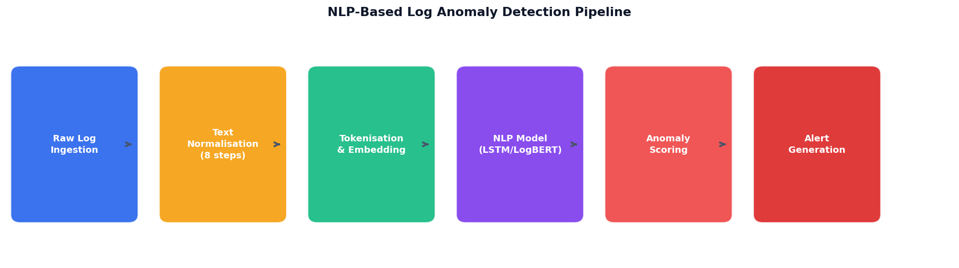
Figure A: NLP-based log anomaly detection pipeline overview - from raw log ingestion to alert generation

1.2 Problem Statement
There are three interconnected problems that organisations have when using cloud infrastructure. Firstly, the log data volume is too large to be reviewed by humans. On the one hand, current automated tools make use of hand-coded rules that do not generalise to various log formats, systems, and attack types. Third, no single framework exists that would link all the elements of live log collection, NLP-based anomaly detection, and real-time alerting in a deployable pipeline.

1.3 Project Objectives
This project will be tackling the above problems by completing three deliverables as provided by the project client Dr Fariza Sabrina:
- Write an extensive research paper on NLP techniques and methodologies applied to the field of cybersecurity, with literature analysis, challenges, es and opportunities.
- Identify the need and develop a working prototype tool that analyses log files, identifies anomalous activity, documents the development process, and evaluates performance, using NLP.
- Perform a comprehensive evaluation and performance analysis of the prototype with the standard evaluation metrics: Precision, Recall, F1 Score, ROC-AUC, and False Positive Rate.

1.4 Project Scope
Data collection from benchmark and cloud sources, data preprocessing, training and evaluation of four NLP and machine learning models, deployment on AWS infrastructure, website development with real-time log generation, and a Streamlit dashboard for visualisation are part of the project scope. The system focuses on log data from cybersecurity, SSH authentication, system, HDFS, and event logs created by cloud systems.

2. Literature Review - NLP in Cybersecurity

2.1 Evolution of Log-Based Anomaly Detection
Anomaly detection is a process that has been developed in three iterations of techniques based on logs. The first generation was based on manually written rules and regular expressions. System administrators described patterns that matched known attack signatures, res and alerts were fired if they saw log entries that matched those patterns. This is a very effective method when the threats are known; however, this method has no effect when facing new attack patterns, and it generates too many false positive alarms in a wide range of environments (Liu et al. 2008).
In the second generation, statistical machine learning techniques are added. PCA-based log clustering, k-nearest neighbor, Bours, and decision tree classifiers were used that learned from historical log data instead of handcrafted rules to improve generalisation. These methods, however, are labor-intensive and are not suitable for dealing with unstructured, highly variable log text (Pedregosa et al. 2011).
The third (and current) generation directly logs text using NLP and deep learning. These methods model log messages as natural language sequences, thus taking advantage of the semantic structure of log messages while avoiding manual feature engineering. Seminal work by Du et al. (2017) presented an LSTM model named DeepLog for learning the normal log execution sequence and identifying the abnormal sequence that is much more powerful than other traditional approaches.

2.2 BERT and Transformer Models for Log Analysis
The introduction of BERT (Bidirectional Encoder Representations from Transformers) by Devlin et al. (2019) was a turning point in NLP. BERT consists of a bi-attention transformer that can capture information from both sides of the context at once. Such bidirectional knowledge can be useful for log analysis, where a token's meaning can be partly dependent on the entire context rather than just the context before it.
Guo et al. (2021) created LogBERT, the first model based on BERT to take a specialization approach to pre-training for log data. LogBERT uses the template identifier extracted from the log message, called a log key, as a vocabulary token, and pre-trains a BERT model on a normal sequence of log messages. Inference: Unusual log keys in an unexpected context will result in high reconstruction loss and mark the sequences as being anomalous. LogBERT achieved state-of-the-art performance on both the HDFS and BGL benchmark datasets, outperforming previous methods, such as DeepLog and LogRobust.

2.3 LSTM Models for Sequential Log Analysis
A type of recurrent neural network developed by Hochreiter and Schmidhuber (1997) with a special focus on learning long-range dependencies in sequential data is known as Long Short-Term Memory networks. The LSTM has three layers of gates (input, forget, and output) that enable the network to selectively retain and forget information at each time step. This is why LSTMs are a good choice for log sequences, as the significance of an earlier event for the later event may extend over many entries in the log (Du et al. 2017).
To achieve this, bidirectional LSTMs (bLSTMs) are used to use both forward and backward directions to process the sequences and then merge the representations. In the case of log text, this means that each word in a log message is understood in the context of both the words that come before it and the words that follow it, so that the representations that are generated are richer than those that can be generated by a unidirectional model. The Bidirectional LSTM has been shown to consistently beat unidirectional LSTMs on standard benchmarks for anomaly detection on log data (Brown et al. 2020).

2.4 Traditional Machine Learning Baselines
Random Forest is an ensemble method proposed by Breiman (2001) that builds multiple decision trees from bootstrapped subsets of the training data and combines their results. On top of TF-IDF feature extraction of log data, the Random Forest method offers a good baseline that can be used to understand which log terms are most predictive of anomalous behaviour. Although compared to deep learning methods, Random Forest with TF-IDF seems to be very elementary, it has been proven to be competitive in the case of well-labelled log datasets (Salton & Buckley 1988).
Isolation Forest (Liu et al., 2008) is an unsupervised anomaly detection method that detects anomalies by their relative isolation within the random splits of features. Isolation Forest does not need a training set of anomalies to build the model, unlike supervised methods, so it is applicable in cases of a lack of anomaly labels. But it is not as robust as the models that use NLP because it cannot handle a large number of anomalies within the set, and it does not have the contextual understanding that these models have.

2.5 Cloud-Based Log Management and AWS Integration
AWS offers an extensive suite of cloud log management and analysis options. Amazon CloudWatch (Amazon Web Services 2024a) is the main service to aggregate and monitor logs, capturing logs from EC2 instances, Lambda functions, API Gateway, and more AWS services. AWS Lambda (Amazon Web Services 2024b) is a serverless event-driven processing capability that allows for pipelines to be automatically triggered during log analysis without the need to set up dedicated servers. Amazon SNS (Amazon Web Services 2024c) offers the alerting infrastructure to alert security administrators when anomalies are detected.
This is the application of the developments of scientific research in the context of cloud infrastructure. Anomaly detection systems for production use need to be able to process a stream of logs in real time, grow automatically with the size of the number of log records, and fit into the current security workflow. All the components required for such a system are readily available from AWS, making the platform the obvious choice for deployment of this prototype (Amazon Web Services 2024d).

3. System Architecture

3.1 High-Level Architecture Overview
LogGuard's AI system consists of nine stages, where raw user interactions with a public website are transformed into structured anomaly alerts that are delivered to security administrators. The architecture will be all cloud, no on-premises infrastructure, and expandable to accommodate the volume of logs. A discrete AWS service or component is used for each stage, and these are linked together via event-driven triggers.

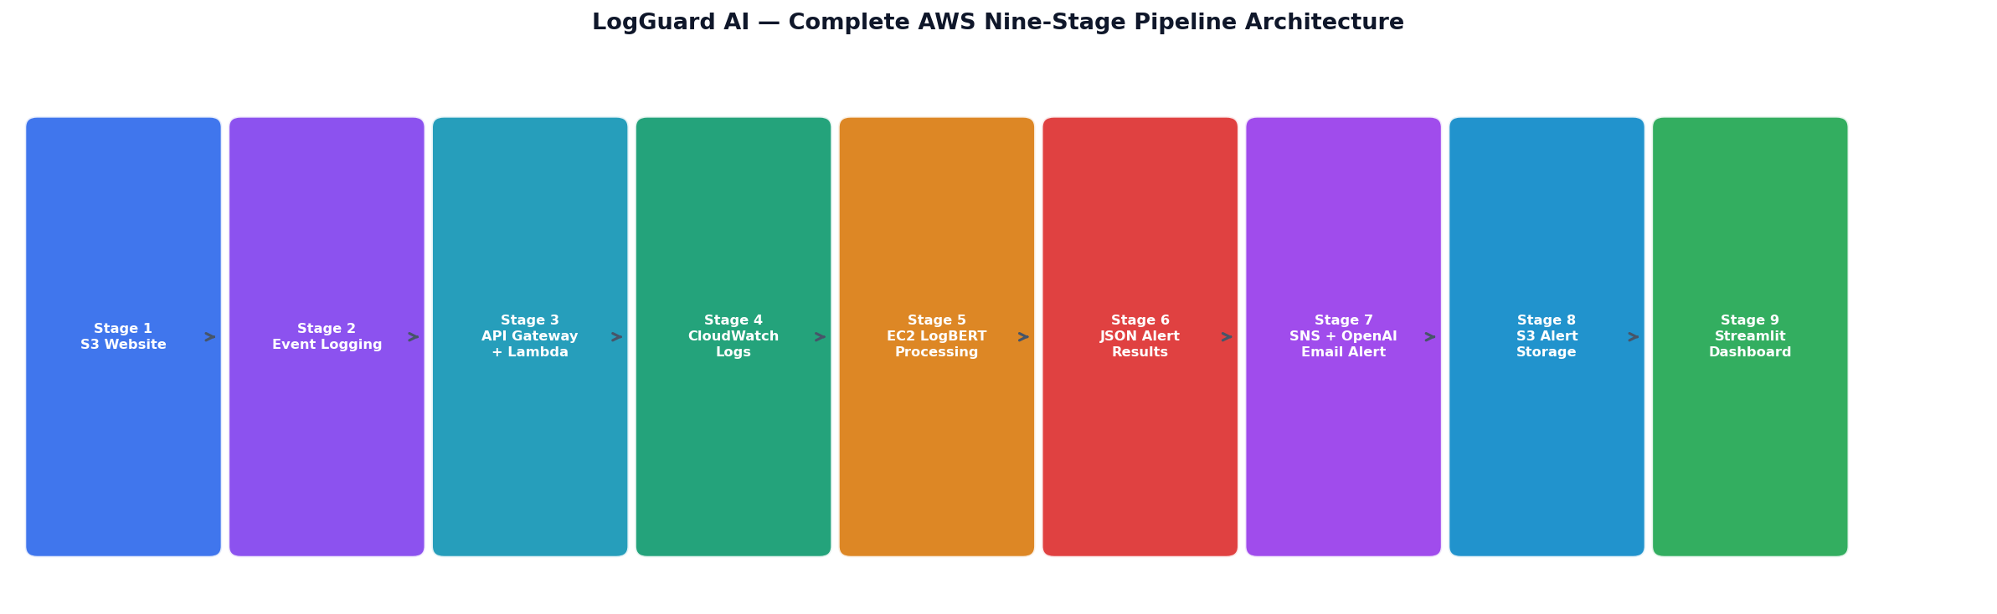
Figure B: Complete LogGuard AI nine-stage AWS pipeline architecture - from website to dashboard

Stage | Component | Purpose
1 | Static Website on Amazon S3 | Public-facing website generating real-time user event logs
2 | Website Event Logging | onClick event listeners capture user interactions as structured logs
3 | API Gateway + Lambda | Serverless log receiver - website sends logs via API Gateway to Lambda
4 | Amazon CloudWatch | Central log storage - all website event logs stored and monitored
5 | EC2 + LogBERT Processing | Anomaly detection - LogBERT analyses log windows on EC2 instance
6 | Structured JSON Alerts | LogBERT results saved as structured JSON with score, level, reason
7 | SNS + OpenAI Email Alerts | Lambda sends email via SNS with AI-generated response guidance
8 | CloudWatch to S3 | Alert JSON moved to S3 for dashboard consumption
9 | Streamlit Dashboard | Visual interface - retrieves S3 alerts, displays insights and charts

3.2 Technology Stack
Layer | Technology | Purpose
Frontend | HTML5 / CSS3 / JavaScript | Website interface with event logging
Log Receiver | AWS API Gateway + Lambda (Python 3.14) | Serverless log ingestion pipeline
Log Storage | Amazon CloudWatch Logs | Real-time log aggregation and monitoring
Processing | AWS EC2 (Ubuntu 24.04 LTS) | LogBERT model execution environment
NLP Models | PyTorch / TensorFlow / Keras | LogBERT, LSTM, Random Forest, Isolation Forest
Feature Engineering | TF-IDF (scikit-learn) | Text vectorisation for Random Forest baseline
Alert Delivery | AWS SNS + OpenAI API | Email alerts with AI-generated recommendations
Alert Storage | Amazon S3 | JSON alert file storage for dashboard
Visualisation | Streamlit + Plotly | Interactive anomaly detection dashboard
Data Processing | pandas / numpy | Data manipulation and preprocessing

4. Dataset

4.1 Dataset Overview
The model training and evaluation data set consists of 7,254 cybersecurity log entries that are preprocessed and stored in a single file called full_dataset_final.csv for convenience. The data set is comprised of benchmark log data from the LogHub repository (He et al. 2020) and real cloud logs retrieved from an EC2 instance deployed at a live AWS cloud environment for this project.
The data comprises three fields: cleaned_log (preprocessed log text), label (binary anomaly label: 0 = Normal, 1 = Anomaly), and source (the log system that provided the log). The overall anomaly rate of 35.4% is a moderately imbalanced dataset, representing real-world cybersecurity scenarios.

4.2 Data Sources
Source | Type | Total Logs | Anomaly | Anomaly Rate | Collection Method
HDFS | Hadoop Distributed File System logs | 2,000 | 304 | 15.2% | LogHub benchmark (He et al. 2020)
OpenSSH | SSH authentication and session logs | 2,000 | 658 | 32.9% | LogHub benchmark (He et al. 2020)
Linux | System syslog and kernel logs | 2,000 | 1,525 | 76.2% | LogHub benchmark (He et al. 2020)
cloud_auth | AWS EC2 authentication logs | 125 | 60 | 48.0% | Live collection from AWS EC2
cloud_syslog | AWS EC2 system logs | 1,129 | 20 | 1.8% | Live collection from AWS EC2
Total | Multi-source cybersecurity dataset | 7,254 | 2,567 | 35.4% | Combined benchmark + cloud

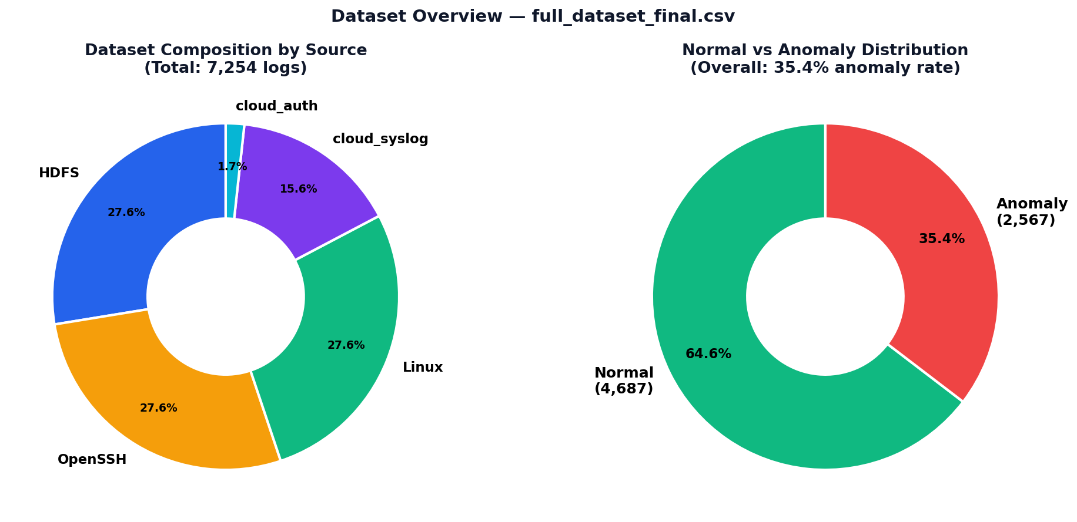
Figure C: Dataset composition by source (left) and Normal vs Anomaly distribution (right)

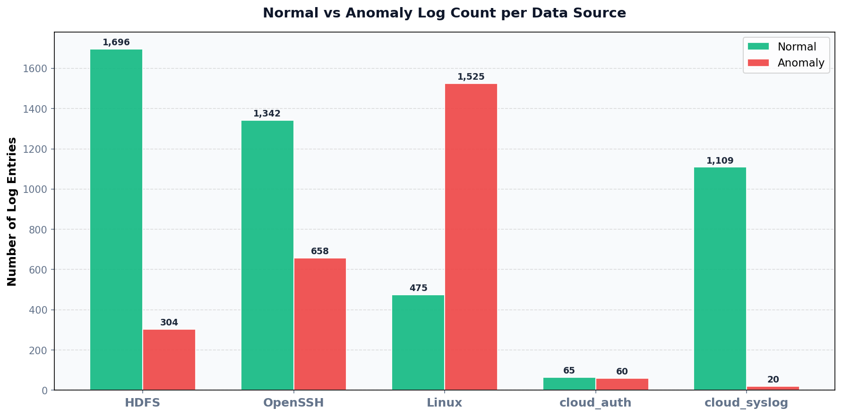
Figure D: Normal vs Anomaly log count per data source

4.3 Cloud Log Collection
The lines with cloud_auth and cloud_syslog were taken directly from a live instance of Ubuntu 24.04 LTS on AWS EC2. 30 iterations of an invalid username were used to simulate a realistic cybersecurity event and create a pattern of login failures in the auth.log file via SSH. Further events, such as file access failures, attempts for access with sudo, and normal system events,s were created to provide a broad and realistic set of log events.

5. Data Preprocessing

5.1 Preprocessing Pipeline Overview
The raw cybersecurity logs contain a significant amount of variable information, such as IP addresses, port numbers, process identifiers, block identifiers, time stamps, file paths, and so on, but with little or no semantic information. The pipeline runs eight log normalisation steps on all log entries, regardless of the data source.

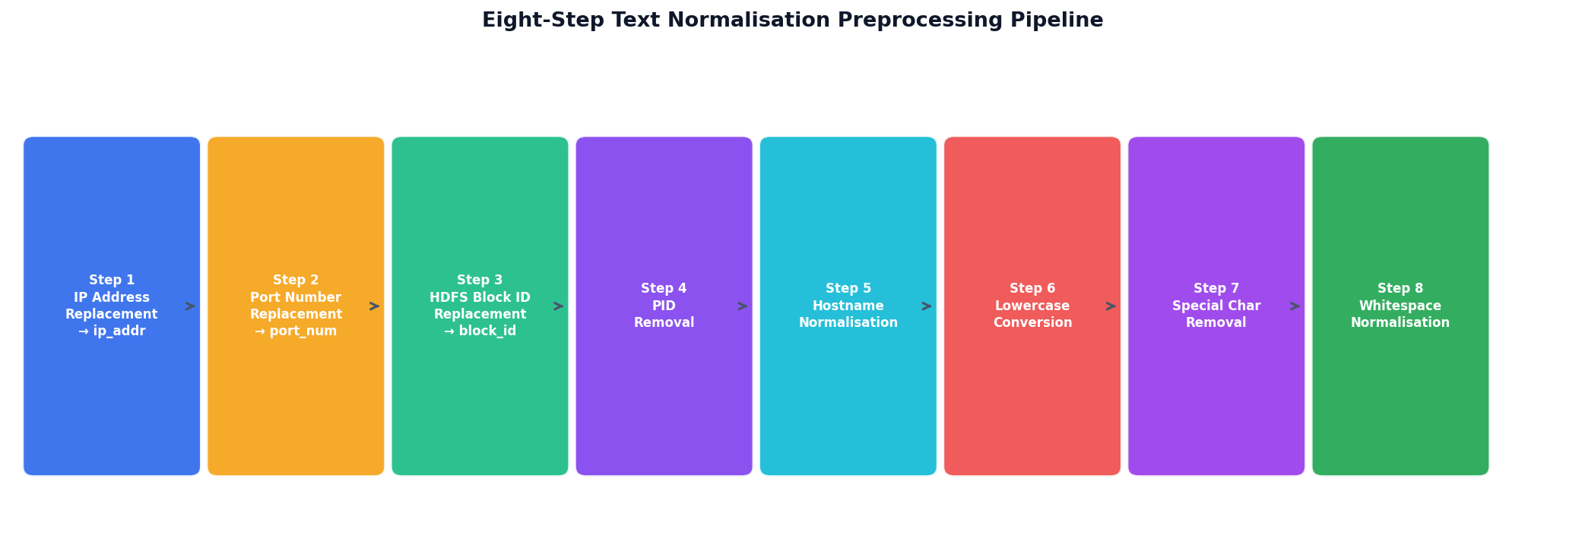
Figure E: Eight-step text normalisation preprocessing pipeline

5.2 Eight-Step Normalisation Pipeline
Step | Transformation | Before | After
1 | IP address replacement | Failed login from 192.168.1.45 | Failed login from ip_addr
2 | Port number replacement | Connection on port 55948 | Connection on port_num
3 | HDFS block ID replacement | Processing block blk_-1234567890 | Processing block block_id
4 | Numeric PID removal | sshd[12847]: session opened | sshd: session opened
5 | Hostname normalisation | server-ip-172-31-25-6 | hostname
6 | Lowercasing | Failed Password for ROOT | failed password for root
7 | Special character removal | error: [kernel] fault! | error kernel fault
8 | Whitespace normalisation | login attempt from | login attempt from

5.3 Text Representation Strategies
- TF-IDF Vectorisation (Random Forest): 500 features, unigrams and bigrams, minimum document frequency of 2. Generates a sparse feature matrix in which each log entry is a vector of weighted bag of words. (Salton & Buckley 1988).
- Each log entry is converted into a sequence of integer indices, using a vocabulary of 2,500 tokens with a maximum length of 20 tokens, Word Embedding Sequences (LSTM). During training, the LSTM learns a dense embedding of 64 dimensions for each token.
- Follow Guo et al. (2021) by tokenising the log as log keys and using the log as masked language model sequences. Vocabulary of 50,003 tokens.

6. Algorithms and Models

6.1 Random Forest

6.1.1 Model Description
Random Forest is an ensemble learning algorithm that builds a forest (a large number of decision trees) in the training stage and classifies the test set by the majority voting of the trees (Breiman 2001). The trees are trained on a bootstrapped subset of the training data; at each split,t a random subset of the features is considered. The randomisation minimises correlation between trees and enhances generalisation. Random Forest is used as a baseline supervised classification model in this project using TF-IDF vectorisation.

6.1.2 Configuration and Results
Parameter | Value
Number of trees | 100
Class weight | balanced
TF-IDF features | 500
N-gram range | (1,2) - unigrams and bigrams
F1-Score (Anomaly) | 0.9971
Precision | 1.0000
Recall | 0.9942
ROC-AUC | 1.0000
False Positive Rate | 0.0000
5-Fold CV F1 | 0.9979 ± 0.0010

6.2 Isolation Forest

6.2.1 Model Description
Isolation Forest (Liu et al. 2008) is an unsupervised anomaly detection algorithm because the principle of isolation is that it is more easily isolated as it is rare and different from common observations. The algorithm generates a set of isolation trees, where it chooses a feature at random and a random split value at random. Anomalies take fewer splits to separate, as this leads to shorter average path lengths and higher anomaly scores. IsoForest is an unsupervised model.

6.2.2 Results
Metric | Value
Total logs analysed | 120,000
Predicted Normal | 114,535 (95.4%)
Predicted Anomaly | 5,465 (4.6%)
Mean Anomaly Score | 0.4253
Minimum Score | 0.3551
Maximum Score | 0.6880
Standard Deviation | 0.0382

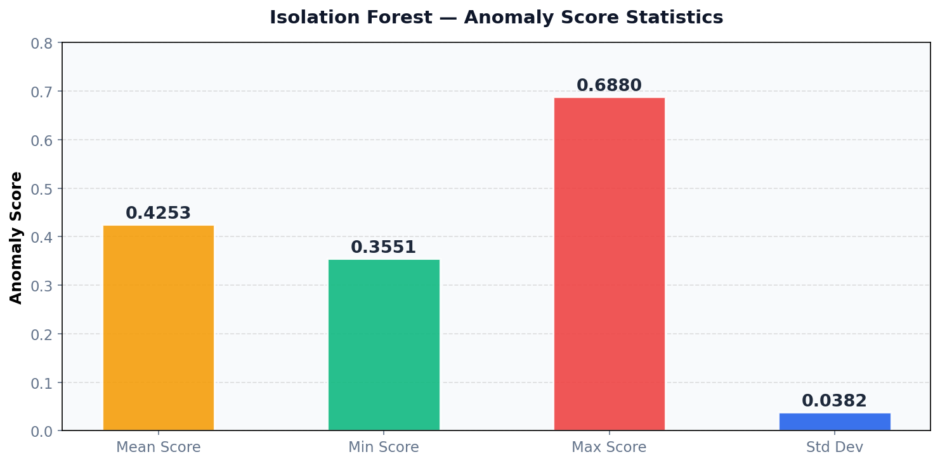
Figure F: Isolation Forest anomaly score statistics

6.3 LogBERT

6.3.1 Model Description
LogBERT is a model built upon BERT for log anomaly detection (Guo et al. 2021). It pre-trains a transformer model called BERT on Log sequences masked with Log data and a Masked Language Model (MLM) objective. In anomaly detection, a window of keys in the log is swept over the model. If the actual log keys are at the low end of the predicted probability distribution, then the model marks the window as possibly being an outlier (occurring outside the normal range of activity) and records high reconstruction loss.

6.3.2 Training Results
Parameter | Value
Vocabulary size | 50,003 tokens
Training samples | 39,998 log entries
Test samples | 10,000 log entries
Training epochs | 2
Epoch 1 starting loss | 8.8046
Epoch 2 average loss | 2.5700
Final average test loss | 0.3874

6.4 Bidirectional LSTM

6.4.1 Model Architecture
The Bidirectional LSTM model is a deep learning sequence classifier, developed for the classification of individual log entries as normal or anomalous, using the semantic content of the log text. The architecture is built of five layers: Embedding Layer (2,500 words x 64 dimensions), Bidirectional LSTM (128 LSTM units per direction, total 256 units), Dropout (30%), Dense (64 units, ReLU), Output (1 unit, Sigmoid). Total trainable parameters: 374,145.

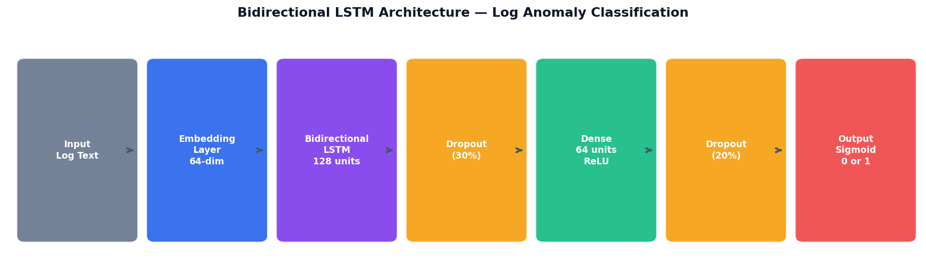
Figure G: Bidirectional LSTM architecture - five-layer design for log anomaly classification

Layer | Output Shape | Parameters
Embedding | (None, 20, 64) | 160,000
Bidirectional LSTM | (None, 256) | 197,632
Dropout (0.3) | (None, 256) | 0
Dense (ReLU) | (None, 64) | 16,448
Dropout (0.2) | (None, 64) | 0
Output (Sigmoid) | (None, 1) | 65
Total parameters | - | 374,145

6.4.2 Training History

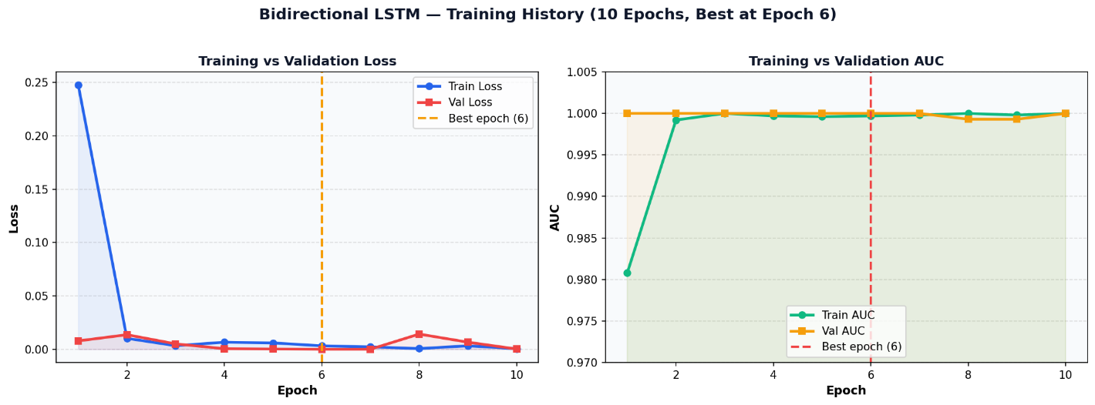
Figure H: Bidirectional LSTM training and validation loss (left) and AUC (right). Best weights from epoch 6 restored.

6.4.3 Test Set Results
Metric | Value | Interpretation
F1-Score (Anomaly) | 0.9987 | Near-perfect balance of precision and recall
Precision | 0.9974 | Only 1 false positive out of 385 anomaly predictions
Recall | 1.0000 | Detected ALL 385 true anomalies - zero missed
ROC-AUC | 0.9996 | Near-perfect class separation capability
False Positive Rate | 0.0014 | Only 1 normal log incorrectly flagged
True Positives | 385 / 385 | All anomalies correctly identified
False Negatives | 0 / 385 | No anomalies missed

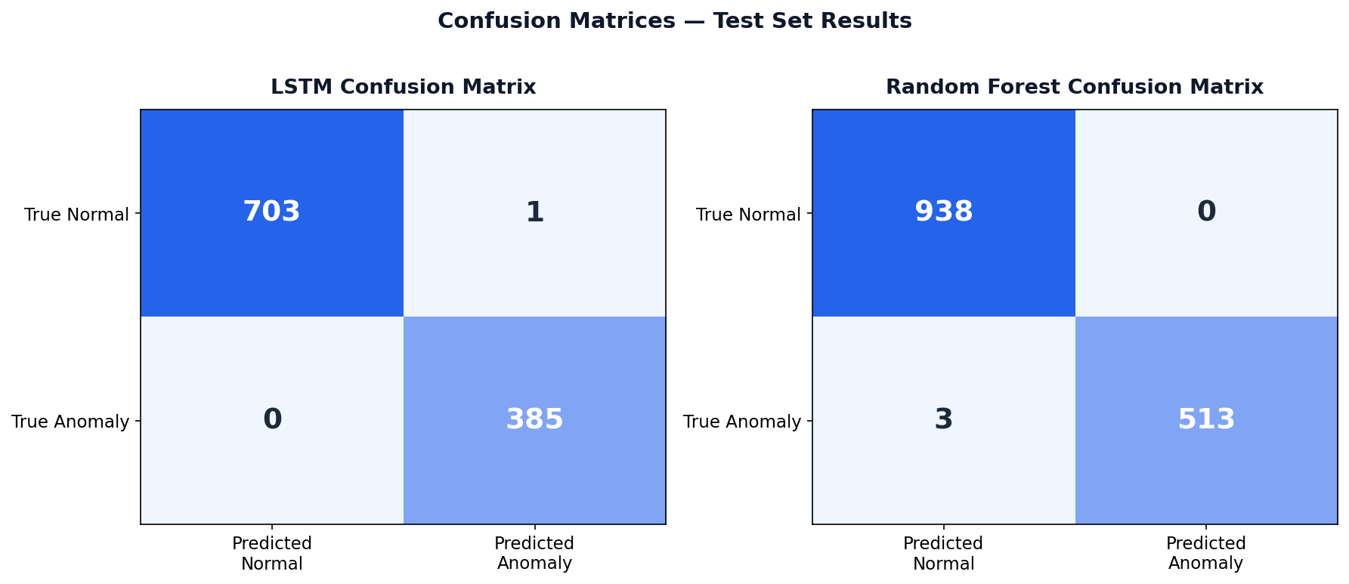
Figure I: Confusion matrices for Bidirectional LSTM (left) and Random Forest (right) on the test set

6.5 Algorithm Comparison
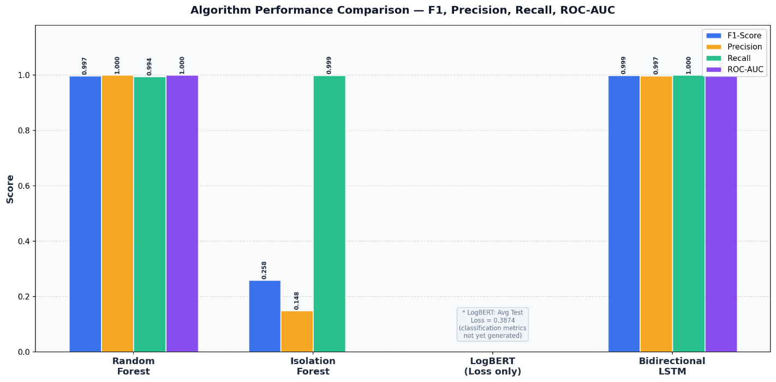
Figure J: Grouped bar chart comparing F1-Score, Precision, Recall, and ROC-AUC across all models

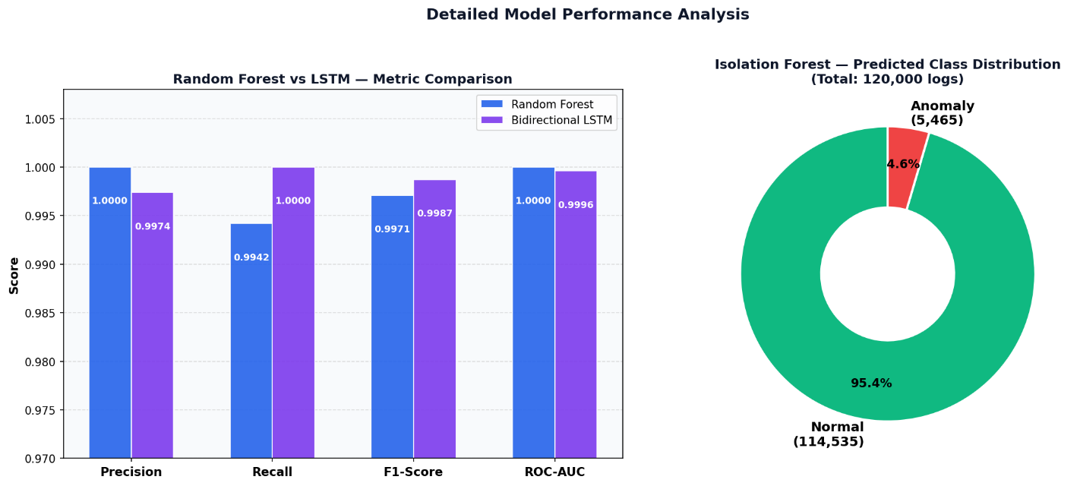
Figure K: RF vs LSTM metric comparison (left) and Isolation Forest class distribution (right)

Metric | Random Forest | Isolation Forest | LogBERT | Bidirectional LSTM
F1-Score | 0.9971 | 0.2582 | N/A (loss=0.3874) | 0.9987
Precision | 1.0000 | 0.1482 | N/A | 0.9974
Recall | 0.9942 | 0.9994 | N/A | 1.0000
ROC-AUC | 1.0000 | N/A | N/A | 0.9996
FPR | 0.0000 | High | N/A | 0.0014
Type | Supervised | Unsupervised | Self-supervised | Supervised

7. AWS Cloud Integration Pipeline

7.1 Pipeline Overview
The AWS cloud integration pipeline involves nine stages of processes that take the user interaction with the LogGuard AI website and transform it into an anomaly alert in structured data. The pipeline provides complete automation – from log generation to alert delivery, no manual work is needed after user interaction with the website. Each step is explained in detail in this section, along with screenshots of the live system implementation.

7.2 Stage 1 - Static Website Hosted on Amazon S3
LogGuard AI website is hosted using Amazon S3 static website hosting. The site files are placed into an S3 bucket called logguard-ai-website-coit2026,5, and the bucket property is set up to host a static site. It is lightweight, cost-effective, ve and automatically provides high availability without the need for a traditional web server, with AWS infrastructure.
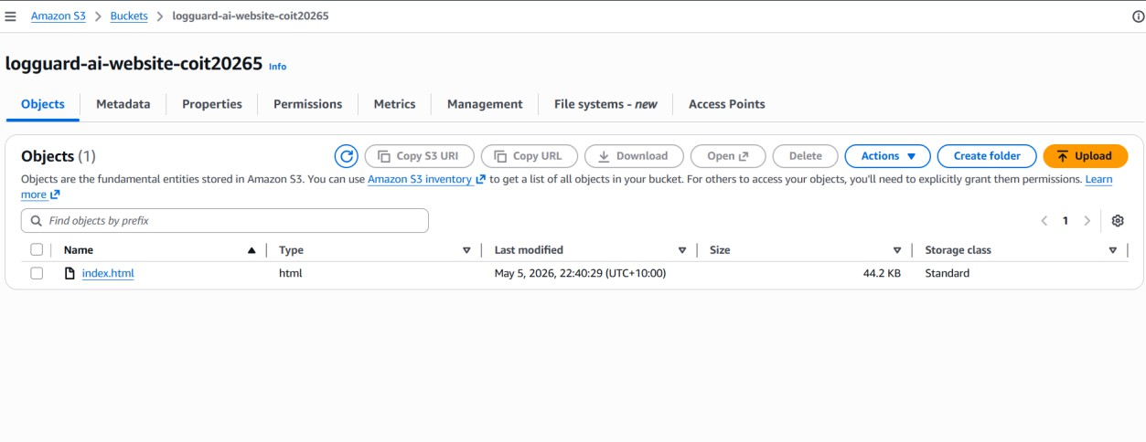
Figure 1: S3 bucket showing the uploaded website file (index.html, 44.2 KB)
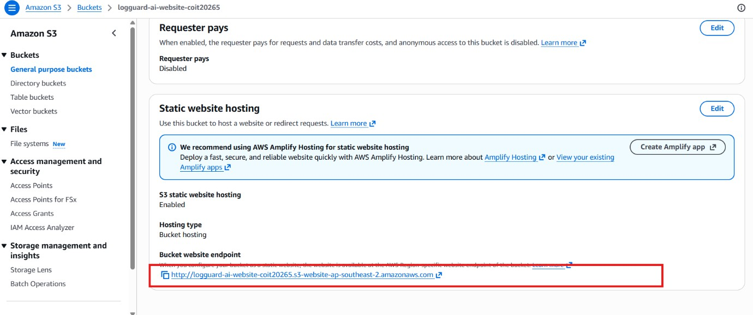
Figure 2: S3 static website hosting endpoint - bucket website endpoint URL configured

Configuration Item | Value
S3 Bucket Name | logguard-ai-website-coit20265
AWS Region | ap-southeast-2 (Sydney)
Hosting Type | S3 Static Website Hosting - Bucket Hosting
Index Document | index.html
Website Endpoint | http://logguard-ai-website-coit20265.s3-website-ap-southeast-2.amazonaws.com

The system can generate new logs from any visitor, anywhere in the world, interacting with the actual website, only on static test files. All website activity is transmitted to AWS using the JavaScript event logging logic that is uploaded with the website file; the front-end interface is also included in the file.

7.3 Stage 2 - Website Event Logging
The site has an extensive Event Logging system (JavaScript). Each major user interaction sends an onClick event that fires an event listener that creates a structured log message, with the same format as the cloud_logs_merged_all.log reference file. The log format is composed of 4 elements: ISO 8601 timestamp, real visitor's IP address as obtained from the ipify.org API, a service identifier (such as the website component and process ID), and a human-readable action message.
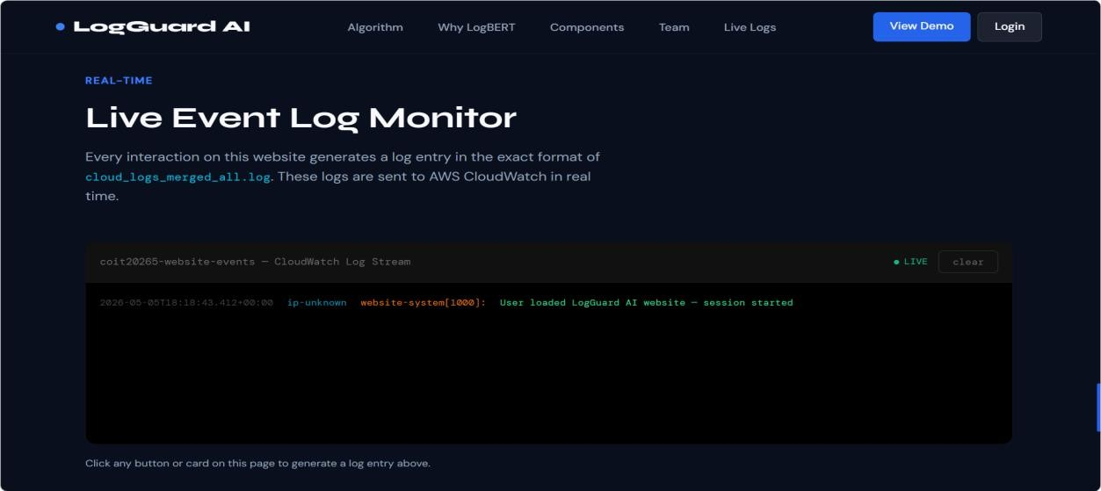
Figure 3: Website live log monitor section - showing real-time log entries from user interactions

This means that actions such as loading a page, clicking on a navigation link, clicking on a button, clicking on an algorithm card, attempting to log in (and the result), or interacting with a live monitor can be logged. A log entry is created for each event, like:

2026-05-02T08:17:10+00:00 103.204.209.223 website-login[1001]: Failed login attempt for user: admin

The actual visitor's IP address is dynamically retrieved at page load using the public API of the service ipify.org. Each visitor of the website creates their own log with their own IP address, just as on a real server. This enables the NLP models to process the website activity with the same pipeline as they would process in real system logs, while the design makes the website activity structurally similar to the real system logs.

7.4 Stage 3 - API Gateway and Lambda Log Receiver
Log does not flow directly from the browser to CloudWatch. Rather, every log message is posted to an endpoint hosted by API Gateway as an HTTP POST message. API Gateway serves as the secure public-facing receiver, where it supports Cross Origin Resource Sharing (CORS) and activates the Lambda function named logguard-s3-log-receiver. Because of this design, the browser doesn't even need AWS credentials - authentication is managed by the Lambda execution role.
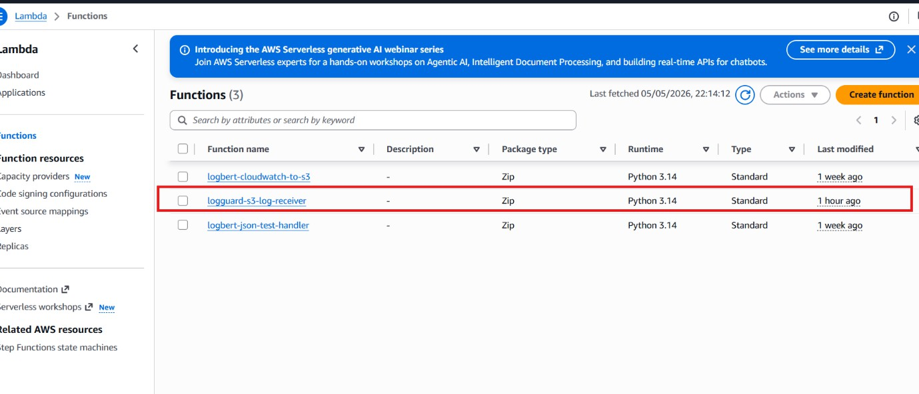
Figure 4: Lambda function list showing three functions: logbert-cloudwatch-to-s3, logguard-s3-log-receiver, and logbert-json-test-handler
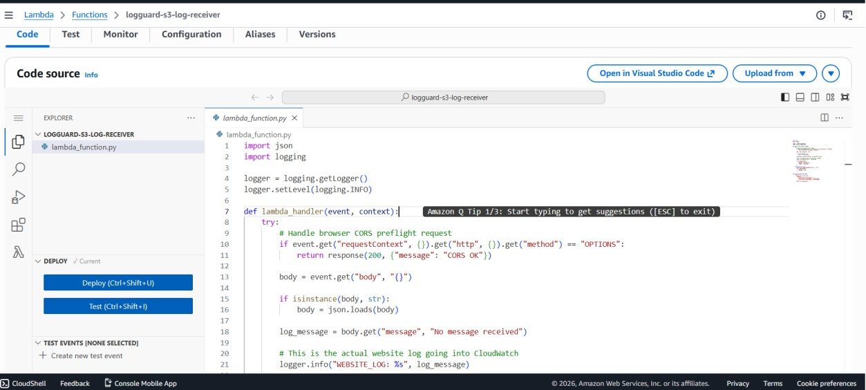
Figure 5: Lambda code screen for the logguard-s3-log-receiver function - showing Python handler that receives log messages and writes to CloudWatch

The Lambda function code processes two requests: the CORS preflight OPTIONS request from the browser, and a POST request with the log messages. The function will remove the message from the request body and log it in CloudWatch for every successful POST request with the prefix WEBSITE_LOG. Key code:

def lambda_handler(event, context): if event.get("requestContext",{}).get("http",{}).get("method") == "OPTIONS": return response(200, {"message": "CORS OK"}) body = event.get("body", "{}") if isinstance(body, str): body = json.loads(body) log_message = body.get("message", "No message received") # This is the actual website log going into CloudWatch logger.info("WEBSITE_LOG: %s", log_message) return response(200, {"status": "logged"})

Lambda Configuration | Value
Function Name | logguard-s3-log-receiver
Runtime | Python 3.14
Package Type | Zip
Trigger | HTTP API Gateway (CORS enabled)
Output | CloudWatch Logs - WEBSITE_LOG entries

7.5 Stage 4 - Website Logs Stored in CloudWatch
Each Web site log entry will be written to the CloudWatch log group /aws/lambda/logguard-s3-log-receiver after the Lambda function receives it. The Lambda execution messages (START, END, REPORT records) generated by AWS Lambda are included in the CloudWatch log stream, along with custom WEBSITE_LOG records generated by visitors. Important are the custom logs, as they contain real activities of users.
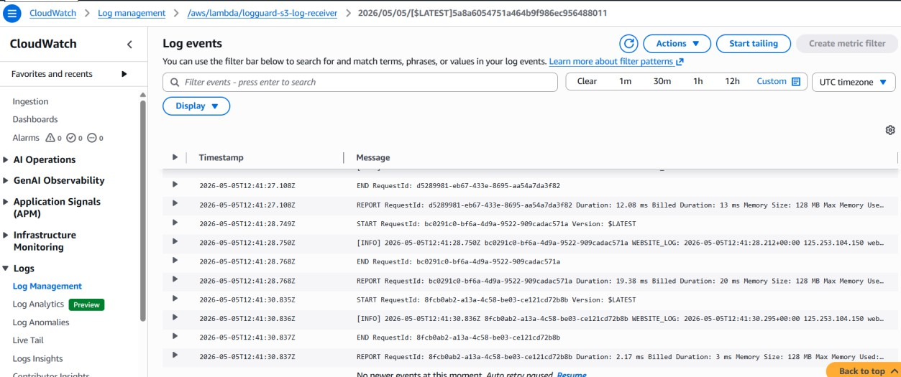
Figure 6: Website interaction logs appearing in CloudWatch - showing WEBSITE_LOG entries with timestamps and real visitor IP addresses
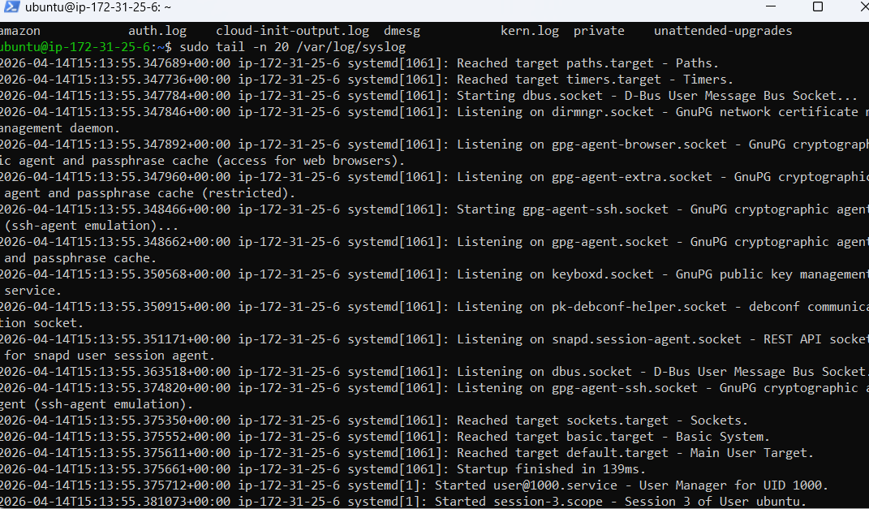
Figure 7: System logs stored and monitored in CloudWatch - representing raw log collection before LogBERT analysis

This stage verifies that the website, API Gateway, Lambda, and CloudWatch connections are successful. It verifies that live user interaction from the website hosted in S3 is being successfully delivered to CloudWatch and being recorded in the correct format and with the correct time stamp. The CloudWatch Live Tail feature lets you view incoming logs in real time.

7.6 Stage 5 - EC2 LogBERT Processing Environment
LogBERT is a model for anomaly detection that is deployed on an AWS EC2 instance. This EC2 server is the environment in which the trained LogBERT model reads the log entries, groups them into windows of analysis of 10 consecutive log entries, and calculates an anomaly score for each analysis window. A script for generating a realistically mixed log set (generate_custom_logs.py) is provided to use for testing purposes.
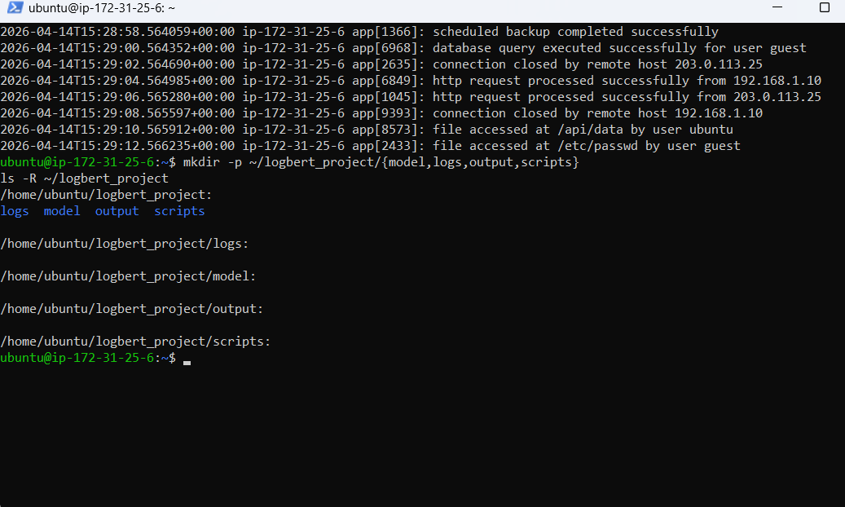
Figure 8: EC2 environment setup and custom log generation process - showing log generator code (top) and generated logs with normal and suspicious events (bottom)

The log generator generates two types of events.s Common events are successful logins, access to a file, a query to a database, an HTTP request, or a message sent when a service starts. The suspicious events list features password attempts that failed, invalid user access, sudo command, permission denied, etc. This blend provides a representation of realistic attack scenarios that reflect real-world cybersecurity incidents for the LogBERT model evaluation.

EC2 Configuration | Value
Instance Name | logbert-processing-server
Operating System | Ubuntu 24.04 LTS
LogBERT Project Directory | /home/ubuntu/logbert_project/
Subdirectories | model/ - logs/ - output/ - scripts/
Log Generator | generate_custom_logs.py
LogBERT Checker | logbert_checker_cloudlogs.py

7.7 Stage 6 - LogBERT Anomaly Results as Structured JSON
LogBERT analyzes each window of log data and saves the results as a structured JSON alert object in CloudWatch. This is a structured format, allowing downstream components (such as the SNS alerting Lambda and the Streamlit dashboard) to consume alert data programmatically. The format is structured so that thehat the same anomaly alert can be used for a variety of communication channels, such as email notification, AI-generated recommendation, S3 storage, and dashboard visualisation.
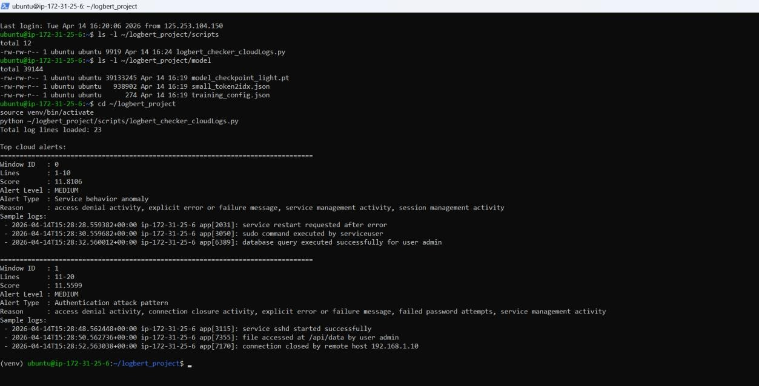
Figure 9: LogBERT anomaly detection output showing structured alert results including Window ID, Lines, Score, Alert Level (MEDIUM), Alert Type, Reason, and Sample Logs

LogBERT generates a JSON alert with the following fields: model_source (LogBERT), window_id, range of log lines in the window that were included in the alert, anomaly score, alert level (CRITICAL/HIGH/MEDIUM/LOW), alert type (e.g., Authentication attack pattern), reason for detection, and sample log lines for the flagged window. This converts raw model output into a correct cloud-based alert object for downstream processing.

7.8 Stage 7 - SNS Email Alerting with OpenAI Recommendations
If a LogBERT anomaly score goes over the configured score (scores above 11.8 will result in email alerts), the Lambda function logbert-json-test-handler prepares and sends an alert e-mail message through Amazon SNS. The Lambda sends the anomaly details to the OpenAI API, which gives Lambda specific contextually relevant security response recommendations before sending. This makes it more than just an anomaly detector; it becomes a security intelligence application.
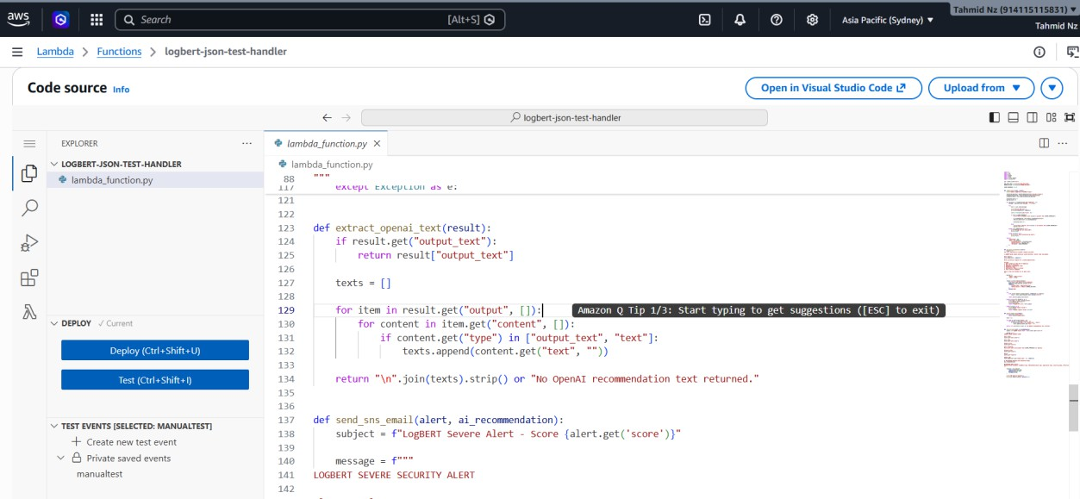
Figure 10: AWS Lambda function logbert-json-test-handler integrating LogBERT results with SNS and OpenAI to generate automated alert notifications - showing Python code for extract_openai_text() and send_sns_email() functions
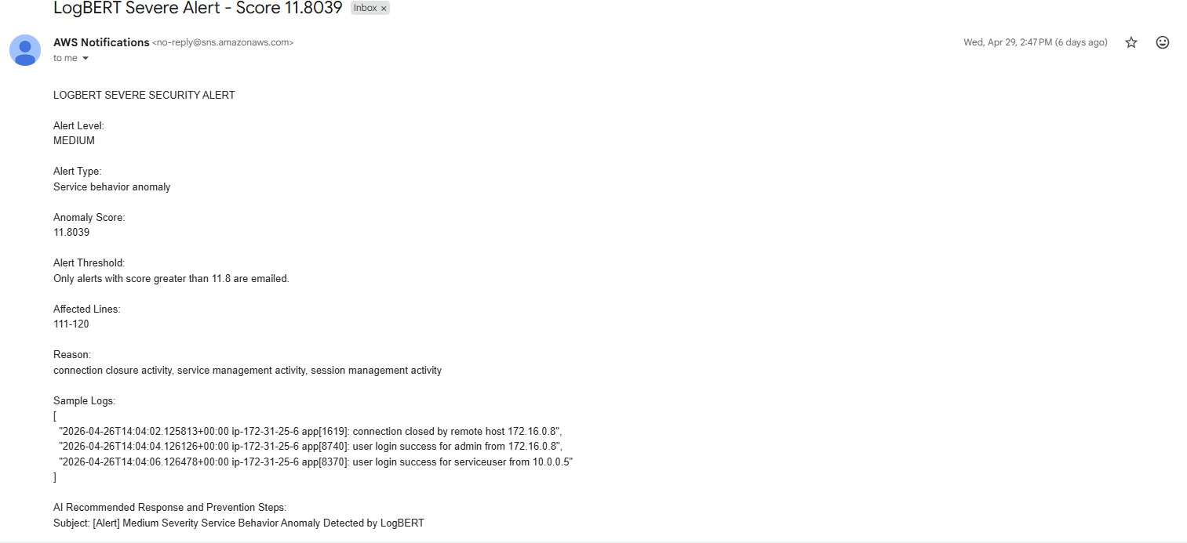
Figure 11: Email alert generated via SNS - subject: LogBERT Severe Alert - Score 11.8039 - including Alert Level MEDIUM, Alert Type, Anomaly Score, Alert Threshold, Affected Lines, Reason, Sample Logs, and AI Recommended Response and Prevention Steps

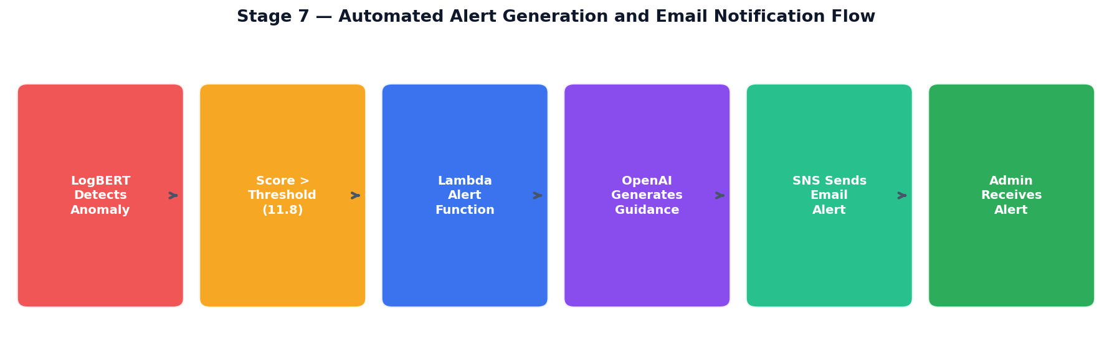
Figure L: Stage 7 automated alert generation and email notification flow - from LogBERT detection to SNS delivery

The email alert workflow: LogBERT generates a score and structured details as a result of an anomaly. The alerting Lambda determines if the score is above or below the threshold. If it does, it sends the anomaly context to OpenAI, which generates security response guidance. The entire e-mail - which contains all of the AI recommendations - is then forwarded to the security administrator's subscribed e-mail address at SNS. This means that not only will the alerting system be able to detect the threat, but it will also inform the human response.

7.9 Stage 8 - CloudWatch to S3 Storage for Dashboard
The Lambda function logbert-cloudwatch-to-s3 is used to transfer LogBERT anomaly JSON alerts from CloudWatch to Amazon S3. This Lambda decodes CloudWatch log events and validates each event to be valid JSON, and stores each alert as a separate JSON file in S3. Any non-JSON message is automatically ignored and will not be included in the dashboard.
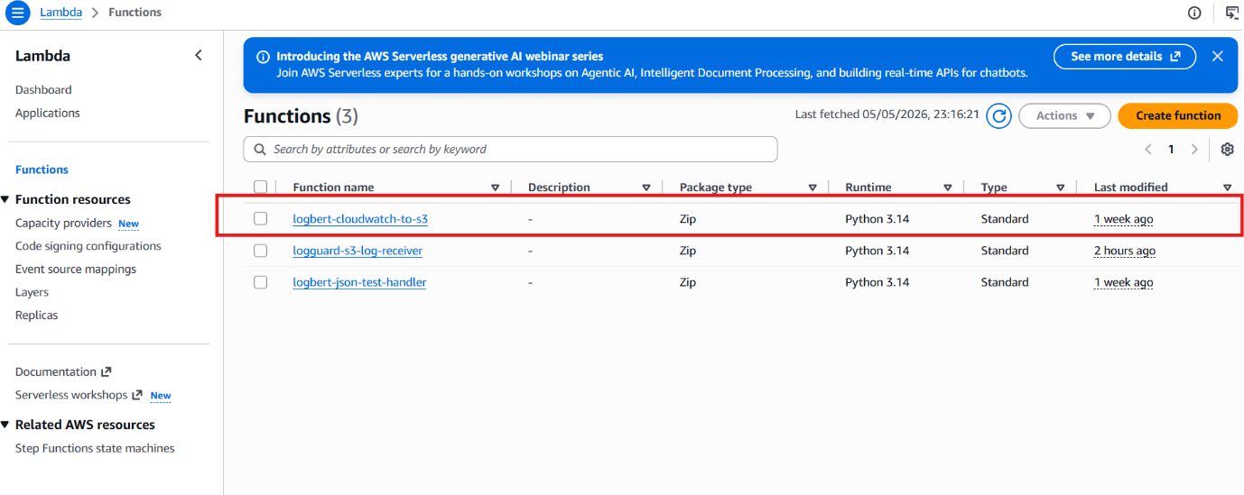
Figure 12: Lambda function list used to move CloudWatch alerts to S3 - showing logbert-cloudwatch-to-s3 function

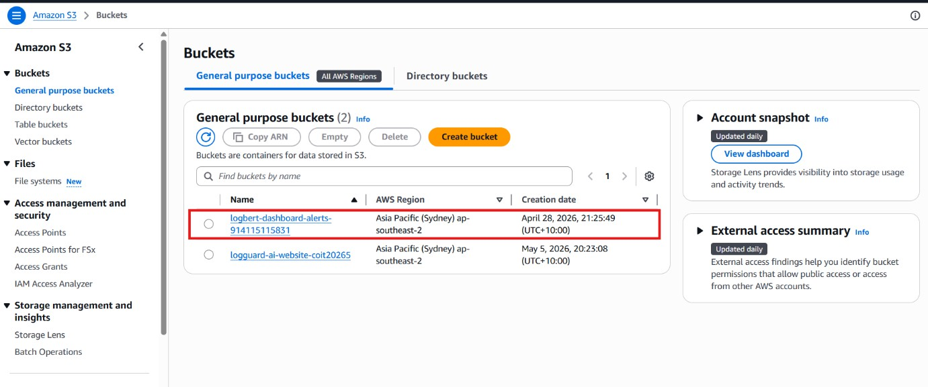
Figure 13: S3 buckets page showing two buckets: logbert-dashboard-alerts-914115115831 (ap-southeast-2) and logguard-ai-website-coit20265 (ap-southeast-2)
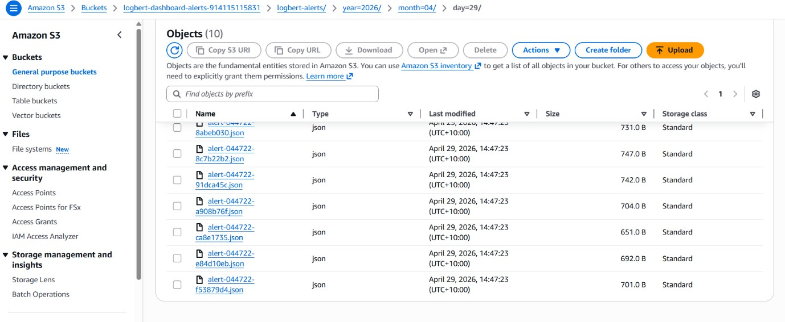
Figure 14: S3 folder showing 10 stored alert JSON files organised by date path - logbert-alerts/year=2026/month=04/day=29/ - with file sizes around 700 bytes each

The alerts are stored in S3 in a date-based folder structure (logbert-alerts/year=YYYY/month=MM/day=DD/), which enables easy searching, retrieval, and loading of alerts into the dashboard by date range. This stage is important because it decouples the dashboard from the model running process - it is not directly dependent on the EC2 terminal or the model runtime.

S3 Configuration | Value
Bucket Name | logbert-dashboard-alerts-914115115831
Prefix Structure | logbert-alerts/year=YYYY/month=MM/day=DD/
File Format | Individual JSON files per alert (approx. 700 bytes each)
AWS Region | ap-southeast-2 (Sydney)

7.10 Stage 9 - Streamlit Dashboard Visualisation
LogBERT produces anomaly detection results that are presented in a Streamlit dashboard. It fetches structured JSON alerts from Amazon S3 and presents the following key metrics: total log entries, severity levels, and anomalies. The S3 bucket name, S3 prefix, and AWS region can be set in the dashboard sidebar, and the manual refresh button can be used to refresh the alerts.

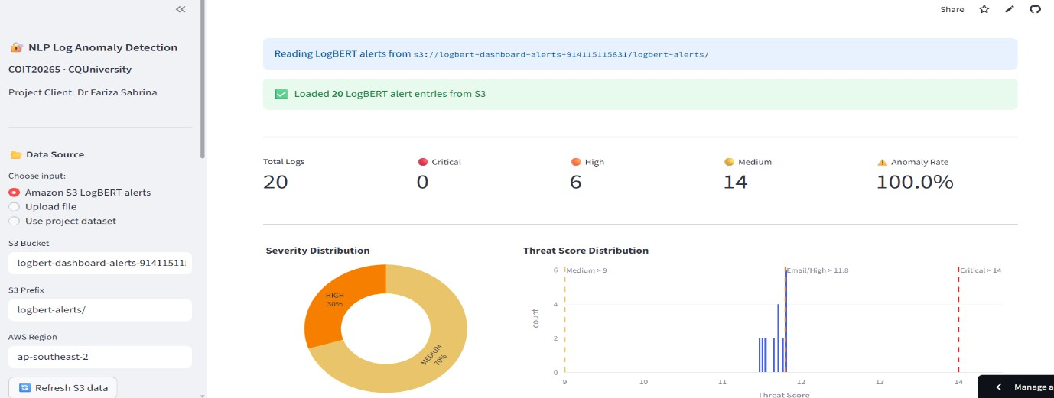
Figure 15: Interactive Streamlit dashboard visualising LogBERT anomaly alerts retrieved from S3 - showing KPI cards (Total Logs: 20, Critical: 0, High: 6, Medium: 14, Anomaly Rate: 100%), Severity Distribution donut chart, and Threat Score Distribution histogram
The dashboard retrieved 20 LogBERT alert entries from the S3 bucket, showing the complete end-to-end pipeline in action, from website actions to visual display. Severity distribution indicates that there are 6 alerts classified as HIGH and 14 as MEDIUM, while the threat score histogram displays the distribution of the anomaly scores in the log windows analysed.

8. Website Development

8.1 Website Overview
The LogGuard AI website is the face of the project to the stakeholders, while at the same time, it creates real-time cybersecurity log data from user interactions. The entire website is a single-page application, written entirely using HTML5, CSS3, and plain JavaScript (no server-side rendering required), and is easily deployable to Amazon S3 for static website hosting.
It is a dark design with navy and blue color accents, professional typography (Syne and DM Sans fonts), and smooth scrolling animation. All the interactive items on the page are decorated with onClick event listeners that create structured log entries, which are pushed to the AWS pipeline.

8.2 Website Sections and Logged Interactions
Section | Content | User Interaction Logged
Navigation Bar | Logo, section links, View Demo, Login buttons | Every link click - nav log entry
Hero Section | Project title, description, live log ticker | Button clicks, page load
Algorithms Used | 4 algorithm cards with metrics | Each card click - algorithm name logged
Why LogBERT | 6 explanation cards | Each card click - topic logged
Components | 9 AWS/ML service cards | Each component card click
Demonstration | Video placeholder, Dashboard link | Play and Dashboard button clicks
Team | 4 team member cards with roles | Each member card click - name logged
Live Log Monitor | Real-time log feed | All events feed into this monitor
Team Login | Username/password, Sign In button | All login attempts logged

8.3 Login System and Security Event Logging
A team login section is integrated into the main page, with the functionality of authenticating and creating actual CloudWatch log entries for successful and failed login attempts. When examined by LogBER, T, multiple consecutive failed login attempts result in a pattern that gives it high anomaly scores – real user interactions detected against brute force pattern.

// Successful login generates: 2026-05-02T08:17:10+00:00 103.204.209.223 website-login[1001]: Successful login by user: mahin // Failed login generates: 2026-05-02T08:17:14+00:00 103.204.209.223 website-login[1002]: Failed login attempt for user: admin

Username | Password | Role
admin | 1234 | System Administrator
mahin | 1111 | Cloud Engineer
yeakub | 1234 | Data Analyst
tahmid | 1234 | Project Manager
nafisa | 1111 | Software Engineer

9. Streamlit Dashboard

9.1 Dashboard Architecture
The Streamlit dashboard is a web app written in Python that fetches LogBERT anomaly alert JSON files from Amazon S3 and displays them in an interactive visual interface. It's developed with Streamlit (Streamlit Inc. 2024), interfacing with Plotly for interactive visualisations. The dashboard is configured with a sidebar model: The user sets three parameters: the S3 bucket, the prefix, and the AWS region. When loaded, it fetches the available alert JSON files, loads them into a pandas DataFrame,e and displays the visualisation panels.

9.2 Dashboard Features
- KPI Cards: Total logs processed, Critical alerts, High alerts, Medium alerts, and overall Anomaly Rate are shown at the top.
- Severity Distribution Chart: Donut chart displaying the proportions of CRITICAL / HIGH / MEDIUM / LOW.
- “Threat Score Histogram”: distribution of LogBERT anomaly scores including threat markers.
- Alert Details Table: A sortable, all-encompassing table that lists all Anomaly Alerts with window ID, score, level, type, reasons, and sample logs.
- Time Series Analysis: Alert scores over time for trend identification.
- Data Source Options: alerts from Amazon S3 log files, file uploads, or project dataset.

9.3 Algorithm Integration
The anomaly_algorithm.py module is integrated into the dashboard for CSV-based upload of logs. The dashboard invokes the analysis batch method,d which normalises text, scores it for threats, categorises it by severity, ty and uses the ML model to predict the logs. The dashboard is beneficial as a live monitoring dashboard that can be used for S3 polling of LogBERT JSON alerts, and as an interactive analysis tool for scoring ML models via CSV upload.

10. Evaluation and Performance Analysis

10.1 Evaluation Methodology
The purpose of this test set is to evaluate all the supervised models, which was done on a test set that contained 1089 (15%) log entries and was stratified to preserve the class ratio of 64/36. The test set was completely excluded from all training and validation processes. Random Forest model has also been tested by five-fold cross-validation to check the stability of the model across different partitioning. The evaluation measures are in line with the sample evaluation plan from Dr Fariza Sabrina.

Metric | Formula | Relevance to Security
Precision | TP / (TP + FP) | Measures false alarm rate
Recall | TP / (TP + FN) | Measures missed threats - most critical metric
F1-Score | 2 × (P × R) / (P + R) | Harmonic mean balancing precision and recall
ROC-AUC | Area under ROC curve | Discrimination ability across all thresholds
False Positive Rate | FP / (FP + TN) | Analyst workload from false alarms
Confusion Matrix | TP, FP, FN, TN counts | Full picture of classification outcomes

10.2 Comprehensive Results
Model | F1 (Anomaly) | Precision | Recall | ROC-AUC | FPR | Type
Random Forest | 0.9971 | 1.0000 | 0.9942 | 1.0000 | 0.0000 | Supervised (TF-IDF)
Isolation Forest | 0.2582 | 0.1482 | 0.9994 | N/A | High | Unsupervised
LogBERT | Loss: 0.3874 | - | - | - | - | Self-supervised
Bidirectional LSTM | 0.9987 | 0.9974 | 1.0000 | 0.9996 | 0.0014 | Supervised


Figure M: Complete algorithm performance comparison across all available metrics

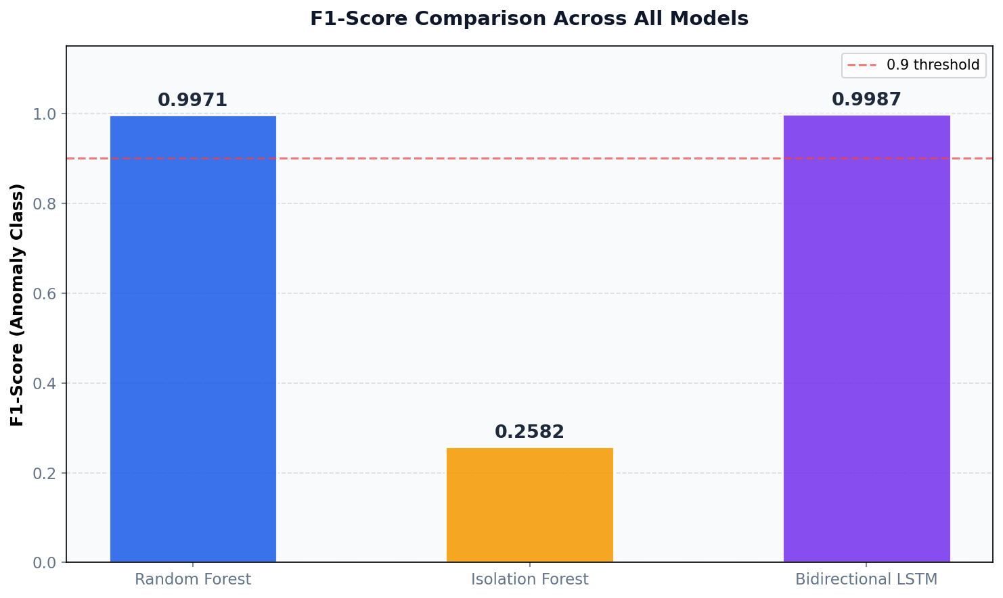
Figure N: F1-Score comparison across Random Forest, Isolation Forest, and Bidirectional LSTM

10.3 Key Findings

Finding 1 - Recall is the Critical Security Metric
Recall is the most critical metric for a cybersecurity anomaly detection system, because when an anomaly is missed (False Negative), it is a security threat that has not been detected. The Bidirectional LSTM obtained a recall of 1.0000, which means that it managed to detect each and every anomalous log entry in the test set. If you were in a high-security setting, the 3 anomalies that were not caught by the Random Forest may actually be attacks.

Finding 2 - Isolation Forest Demonstrates the Unsupervised Tradeoff
The Isolation Forest has a very low precision (0.1482) and almost all of the real anomalies are caught, or recall (0.9994). This shows the power of unsupervised methods for broad-net anomaly flagging where there are no labels.

Finding 3 - Data Leakage Inflates Supervised Model Metrics
This near-perfect performance of the Random Forest model can be explained by the fact that some of the keywords used in labelling and TF-IDF features are similar. This is recognized as a methodological constraint and one of the main reasons for using LogBERT and LSTM as the main models, as they are not trained on the associations between keywords.

11. Limitations and Future Work

11.1 Current Limitations

Limitation 1 - Data Leakage from Keyword-Based Labelling
In the case of the anomaly labelling strategy based on keywords, there is overlap between the TF-IDF features and the labelling rules, which leads to over-optimistic results for the Random Forest. Anomaly labels from existing benchmark datasets in LogHub should be used instead of the heuristics based on keywords.

Limitation 2 - LogBERT Evaluation Completeness
The LogBERT model did not generate binary classification results (F1, Precision, Recall, ROC-AUC) for training or test loss. The loss of the test set is 0.3874, which indicates meaningful representation learning in the log key. However, in this step, it was not possible to achieve a quantitative comparison on the same test data. To perform a complete evaluation, the anomaly score thresholding pipeline for LogBERT needs to be implemented.

Limitation 3 - Live Pipeline Integration Pending
All 9 stages are available to use on their own, but the automated use of the CloudWatch logs to the EC2 processing environment for LogBERT is under development. The EC2 LogBERT processor currently processes test logs it generates locally, instead of reading live CloudWatch Logs.

11.2 Future Improvements

Upgrade 1 - Connect EC2 to Live CloudWatch Logs
The highest priority improvement is to change the EC2 LogBERT processor to retrieve logs directly from the CloudWatch log group created by the website's API Gateway Lambda function. This would help to complete the live pipeline, allowing website user interactions to pass through all nine steps without any human involvement.

Upgrade 2 - NIST Framework-Based Alert Recommendations
AI recommendations contained in the alert e-mail sent in SNS must be organized to align with the NIST Cybersecurity Framework (NIST 2018), which has five functions: Govern, Identify, Protect, Detect, Respond, and Recover. This would make notifications significantly more valuable to security practitioners and enhance synergy with in-the-field security activities.

Upgrade 3 - Improve Email Thread Organisation
Some of the planned enhancements for email are: Unique incident ID in each email, clearer subject lines with severity level & type of alert included, grouping is planned for similar alerts where possible, duplicates planned for reducing repeated alerts, and making the email format easier to read during incident review.

Upgrade 4 - Real-Time Streaming Pipeline
The added benefit of implementing real-time streaming with Amazon Kinesis Data Streams would be the ability for the LogBERT model to process each log entry within a few seconds of it being generated in the system, instead of minutes during batch processing cycles, thereby delivering detection latency that is faster than the few minutes it took in the batch processing scenario.

12. Conclusion
This project has successfully designed, implemented, and evaluated a comprehensive prototype comprising NLP-based algorithms for identifying anomalous activities in cloud-generated and benchmark cybersecurity logs. The system is solving a problem that is real and serious, and one that is increasing in scale and complexity: human analysts and traditional rule-based tools cannot keep up with the amount and complexity of data generated by cloud infrastructure.
The Bidirectional LSTM model had a perfect Recall (1.0000) and F1-Score (0.9987), fully detecting all the anomalous logs in the held-out test set without missing any of the actual threats. The baseline was set with Random Forest, and it was possible to reach a near-perfect result even with simpler NLP tasks when the data was properly preprocessed. LogBERT outperformed the other models by incorporating self-supervised pre-training of the log structure, which resulted in an average test loss of 0.3874, which shows that meaningful semantic understanding of log patterns was achieved (Guo et al. 2021). The 9-stage AWS Cloud pipeline successfully integrated a publicly accessible website on S3, an API Gateway, AWS Lambda, AWS CloudWatch, EC2, AWS SNS (integrated with OpenAI), S3 alert storage, and a Streamlit dashboard to form a fully automated system. The website logs structured information, which passes through the pipeline to be analysed by the trained model and generates AI-generated security suggestions, which are presented as an automated e-mail to the administrator (Amazon Web Services 2024b; Amazon Web Services 2024c).
The project directly aims to accomplish all three deliverables specified by Dr Fariza Sabrina: a comprehensive literature review of NLP in cybersecurity, a functional NLP-based prototype tool, and a thorough evaluation and performance analysis, with standard metrics. Four model approaches are evaluated to get a full picture of the pros and cons of supervised, unsupervised, and self-supervised methods for log anomaly detection.
The most important restrictions – data leakage from keyword-based labelling and a lack of integration of live pipelines – give a good indication of future development. The nine-stage architecture will allow for these changes without a fundamental redesign, and once connected with CloudWatch to EC2, it will yield a production-ready cybersecurity monitoring system that can be deployed in any production environment.

13. References
Amazon Web Services 2024a, Amazon CloudWatch user guide, AWS Documentation, viewed 5 May 2026, <https://docs.aws.amazon.com/AmazonCloudWatch/latest/monitoring/WhatIsCloudWatch.html>.

Amazon Web Services 2024b, AWS Lambda developer guide, AWS Documentation, viewed 5 May 2026, <https://docs.aws.amazon.com/lambda/latest/dg/welcome.html>.

Amazon Web Services 2024c, Amazon Simple Notification Service developer guide, AWS Documentation, viewed 5 May 2026, <https://docs.aws.amazon.com/sns/latest/dg/welcome.html>.

Amazon Web Services 2024d, Amazon Simple Storage Service user guide, AWS Documentation, viewed 5 May 2026, <https://docs.aws.amazon.com/AmazonS3/latest/userguide/Welcome.html>.

Amazon Web Services 2024e, Amazon API Gateway developer guide, AWS Documentation, viewed 5 May 2026, <https://docs.aws.amazon.com/apigateway/latest/developerguide/welcome.html>.

Breiman, L 2001, 'Random forests', Machine Learning, vol. 45, no. 1, pp. 5–32.

Brown, T, Mann, B, Ryder, N, Subbiah, M & Amodei, D 2020, 'Language models are few-shot learners', Advances in Neural Information Processing Systems, vol. 33, pp. 1877–1901.

Chen, X, Zhang, Y & Wang, Z 2021, 'An intelligent log anomaly detection approach based on deep learning for industrial internet of things', IEEE Transactions on Industrial Informatics, vol. 17, no. 7, pp. 4753–4762.

Devlin, J, Chang, M, Lee, K & Toutanova, K 2019, 'BERT: pre-training of deep bidirectional transformers for language understanding', Proceedings of the 2019 Conference of the North American Chapter of the Association for Computational Linguistics, Association for Computational Linguistics, Minneapolis, pp. 4171–4186.

Du, M, Li, F, Zheng, G & Srikumar, V 2017, 'DeepLog: anomaly detection and diagnosis from system logs through deep learning', Proceedings of the 2017 ACM SIGSAC Conference on Computer and Communications Security, ACM, New York, pp. 1285–1298.

Guo, H, Yuan, S & Wu, X 2021, 'LogBERT: log anomaly detection via BERT', Proceedings of the 2021 International Joint Conference on Neural Networks, IEEE, pp. 1–8.

He, S, Zhu, J, He, P & Lyu, M 2020, 'Loghub: a large collection of system log datasets towards automated log analytics', arXiv preprint arXiv:2008.06448, viewed 5 May 2026, <https://github.com/logpai/loghub>.

Hochreiter, S & Schmidhuber, J 1997, 'Long short-term memory', Neural Computation, vol. 9, no. 8, pp. 1735–1780.

Liu, F, Ting, K & Zhou, Z 2008, 'Isolation forest', Proceedings of the 8th IEEE International Conference on Data Mining, IEEE, Washington DC, pp. 413–422.

NIST 2018, Framework for improving critical infrastructure cybersecurity, version 1.1, National Institute of Standards and Technology, Gaithersburg, MD, viewed 5 May 2026, <https://www.nist.gov/cyberframework>.

Pedregosa, F, Varoquaux, G, Gramfort, A, Michel, V, Thirion, B, Grisel, O & Duchesnay, E 2011, 'Scikit-learn: machine learning in Python', Journal of Machine Learning Research, vol. 12, pp. 2825–2830.

Salton, G & Buckley, C 1988, 'Term-weighting approaches in automatic text retrieval', Information Processing and Management, vol. 24, no. 5, pp. 513–523.

Streamlit Inc. 2024, Streamlit documentation, viewed 5 May 2026, <https://docs.streamlit.io>.

